­

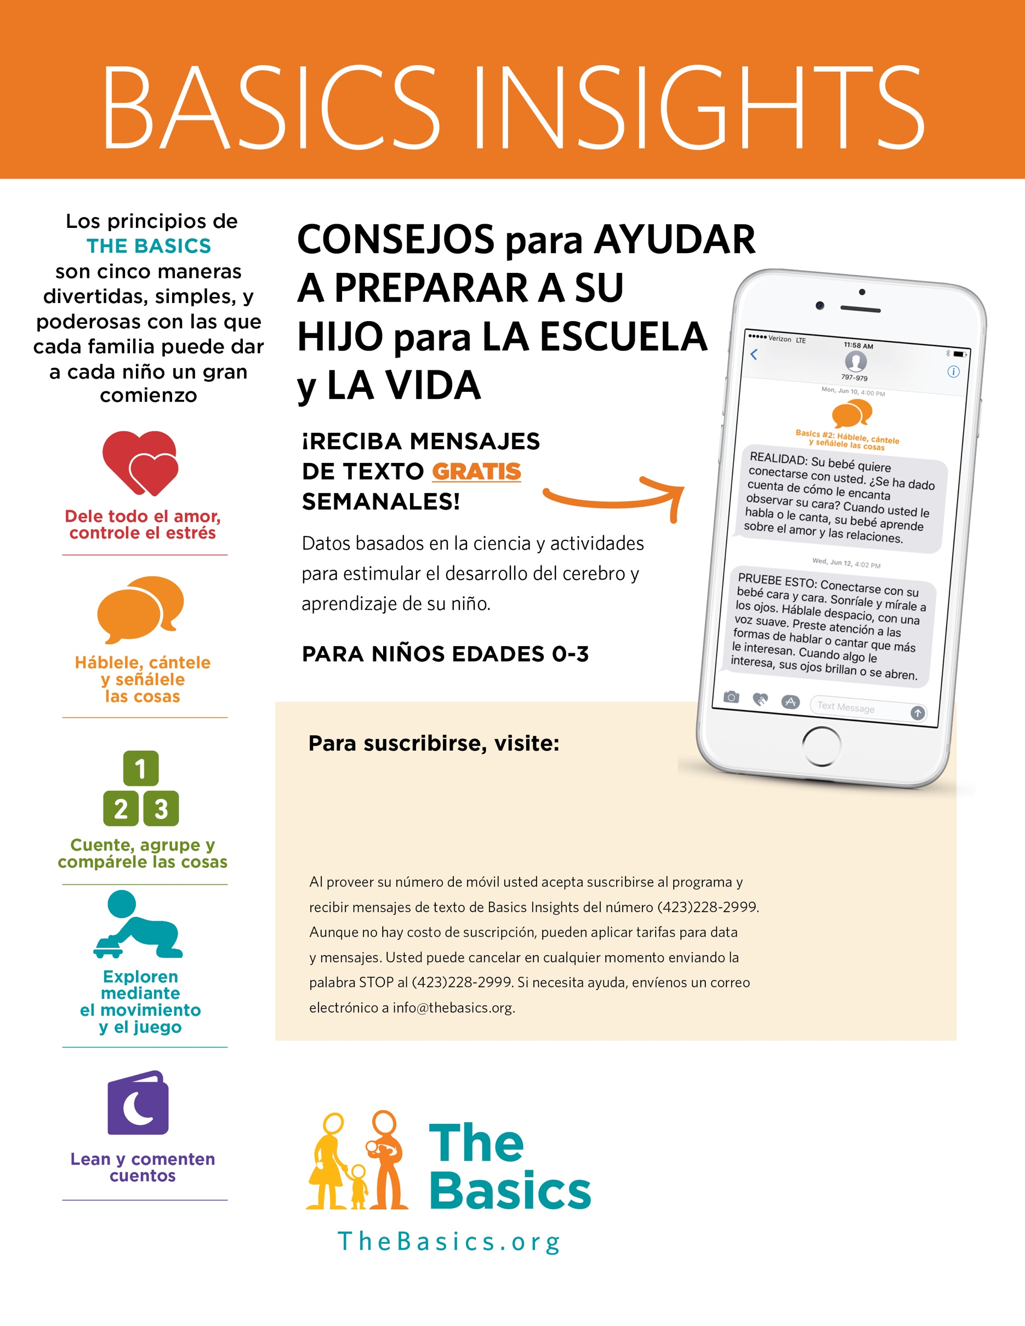

**¡Escanee aquí!**

[**https://partners.mybliss.ai/basics-insights/NPS10636**](https://partners.mybliss.ai/basics-insights/NPS10636)

